# Week 1: Introduction to Machine Learning

## Supervised vs. Unsupervised Machine Learning

### Supervised Learning

* + Algorithms learn **input → output** or **X (input) → Y (output label)**
    - You give the algorithm examples with the correct output so the algorithm can learn for a given input
      * → over time the algorithm will be able to take the input variable (X) without the output variable and give a reasonable output due to the learning it did
      * Algorithms after learning can take a new input variable (X) and produce a new output variable (Y) that is reasonable
    - Example: Ad, User info (X) → Click? (0/1) – *Application is online advertising*
      * Train algorithm with information regarding user info and the ad and whether or not they click the advertisement. If they do, you know what users are likely to click on a certain kind of advertisement
  + Example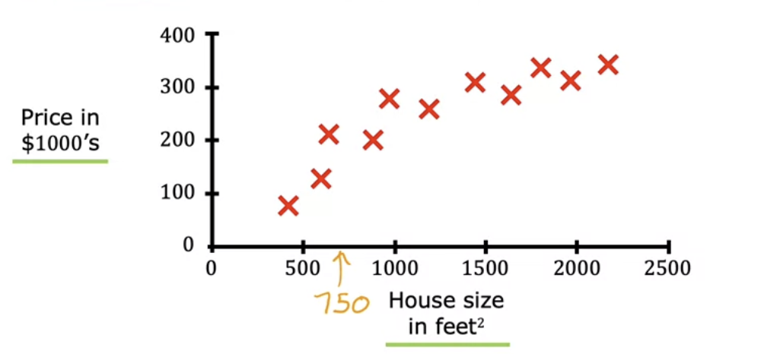
    - There are some input variables and output prices already listed
    - A friend wants to the know the price for a 750 ft2 home
      * Algorithm can provide a straight line fit to determine the price of the house = approximately $150K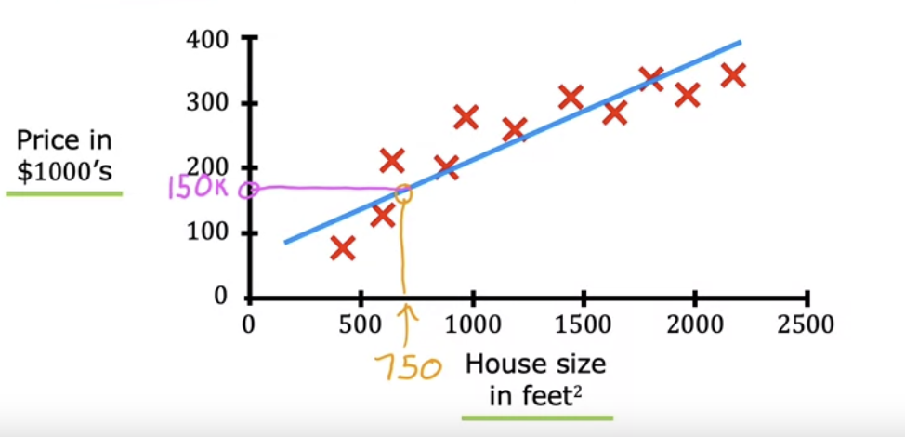
      * Can also use a curved line - Price of house comes out closer to $200 K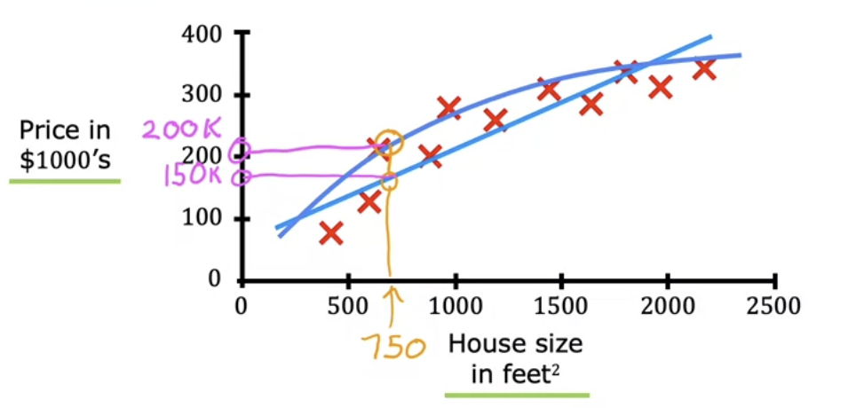
    - This is supervised learning because we gave the algorithm a data set with answers to predict a new X value
      * In this example we used a process called **regression** in order to get an output of infinitely many possible values
        + *One of the major supervised learning algorithms*
  + Classification algorithm
    - Example: Trying to classify whether tumors are benign or malignant
      * Given data set to algorithm 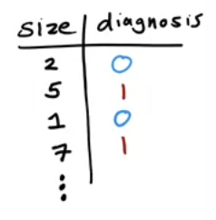
        + Size of Tumor vs Diagnosis (0 = benign, 1 = malignant)
      * 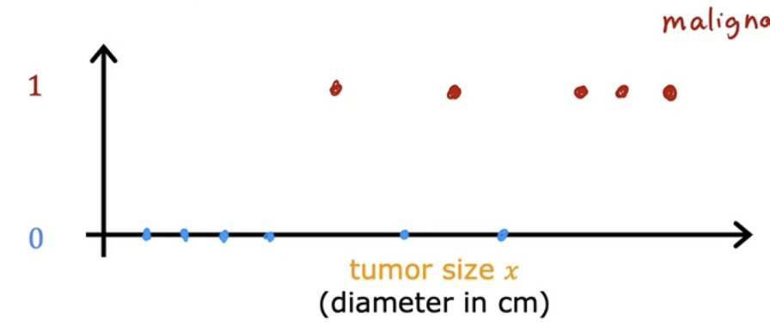
        + Blue dots on 0 axis = benign, Red dots on 1 axis = malignant
        + In this algorithm it is different since the algorithm can only predict to classify two possible diagnoses/output variables. In regression there are an infinite number of output variable possibilities
        + Another way to show this is: 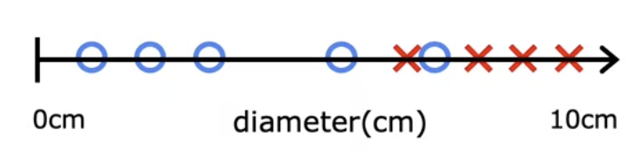

Algorithm will try to predict whether a new tumor (not in the data set is benign or malignant)

* + - * + Classification can also provide an output where there is more than two options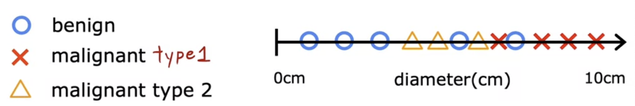
      * In classification, output is often referred to as class or category
        + Could be non-numeric
    - Example: **Two or more inputs** could also be used to predict whether a tumor is malignant or benign
      * Age and tumor size are inputs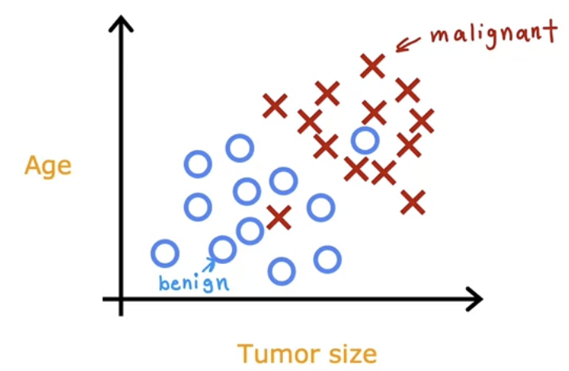
      * To predict whether a person has a tumor or not, the leanring algorithm might use a boundary approach 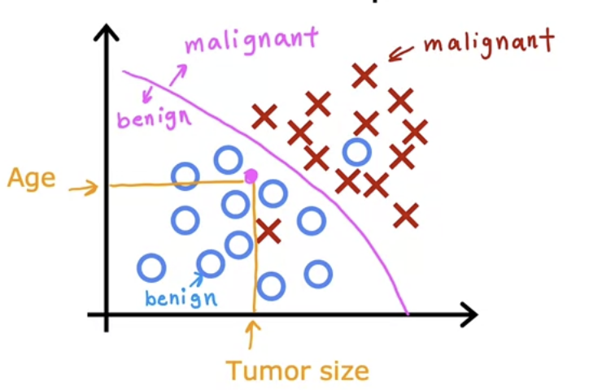

### Unsupervised Learning

* + Data is given without any output labels (Y value), but is given input values (X values)
    - Example: Not given information regarding whether tumors are benign or malignant. Our goal is just to find something interesting in the unlabeled data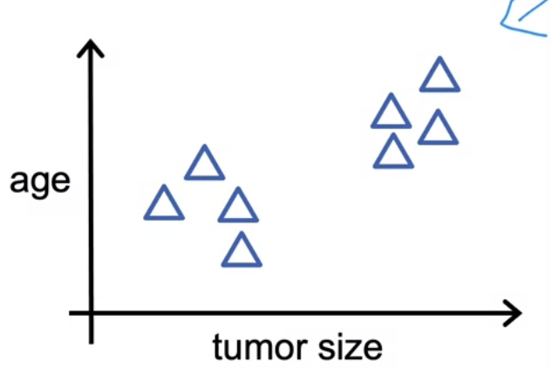
      * Algorithm may decide data can be assigned to different clusters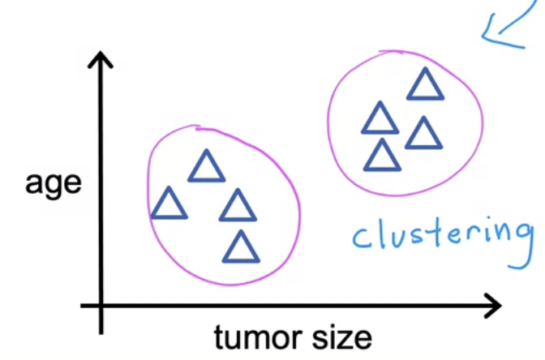
        + This is known as a **clustering algorithm - grouping related values together**
    - Example: Google news using common words to cluster articles together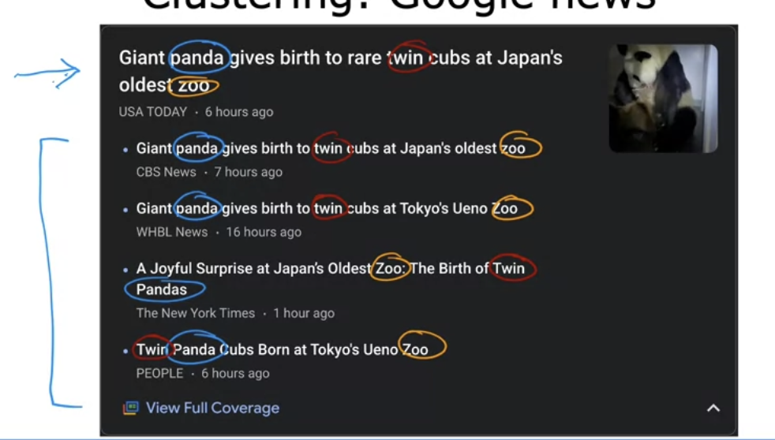
  + Another possible algorithm - **Anomaly Detection**
    - Used to find usual data points
  + Another possible algorithm - **Dimensionality Reduction**
    - Take big data set → compress data set using fewer numbers (without losing information)

## Practice Quiz: Supervised vs. unsupervised learning

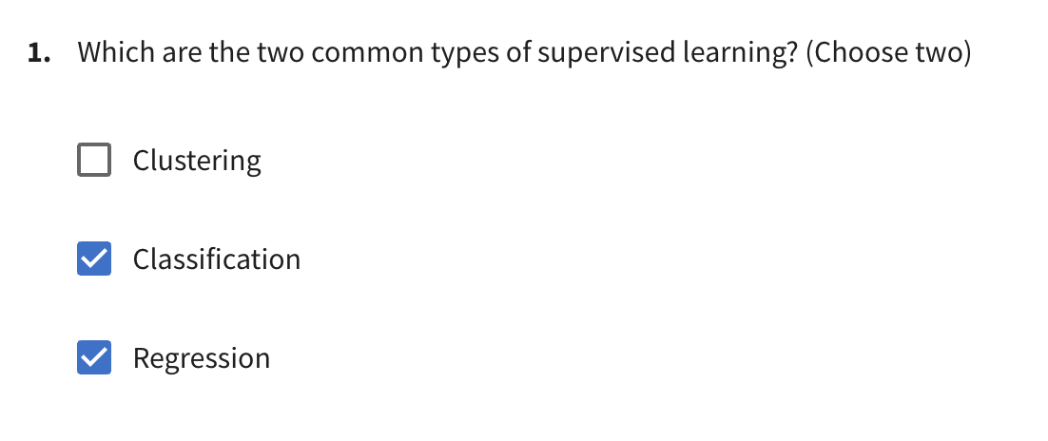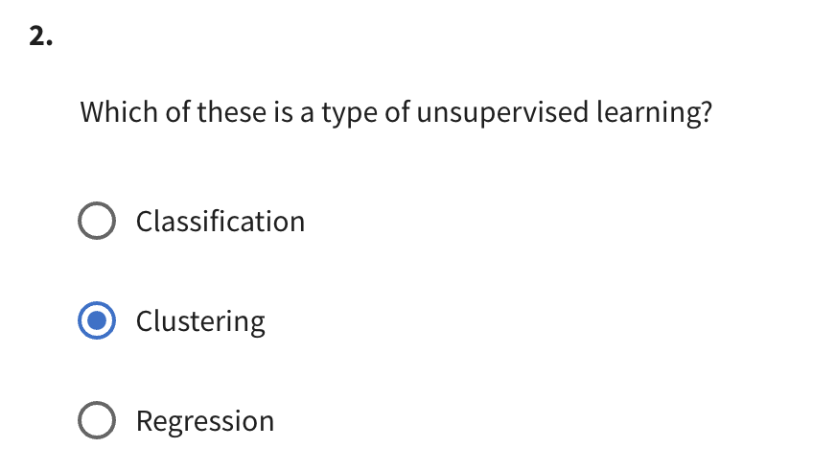

## Regression Model

### Linear Regression Model

* + Can fit a model to a straight line (Example below)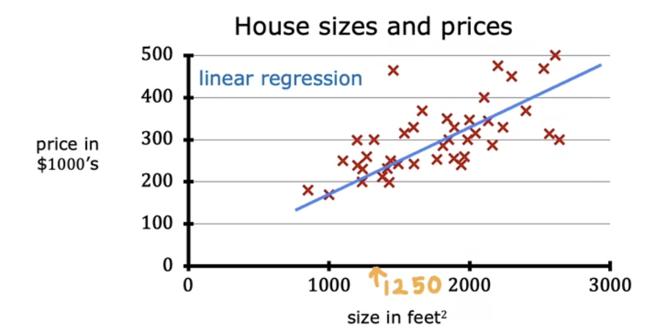
    - Cost of a 1250 ft2 house is ~220k
    - Example of a supervised learning model since the data has “right answers”
      * Regression model since it predicts a number
        + Infinitely many possible outputs
  + Could be helpful to see the data as a data table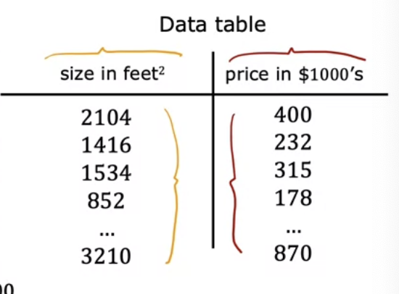
  + Terminology and Notation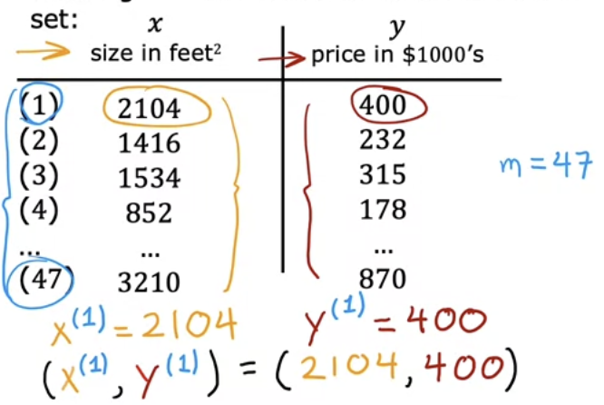
    - Terminology
      * The data set that you use to train a particular model is called a **training set**
    - Notation
      * x = “input” variable or feature
      * y = “output” variable or “target variable”
      * m = number of training examples
      * (x, y) = single training example
      * (x(i), y(i)) = ith training example
        + i refers to a specific row in the table or the ith training example
        + Index of the training set
        + **Not exponent**
  + Supervised learning has both input and outputs in a *training set* → produce a *training algorithm* → produces a *function (f)* or hypothesis or model
    - The *function* takes a new input (x) and produces a new output prediction (ŷ)
      * The output prediction is the estimated value of y (target)
        + This is the actual value of y
    - How to represent *f?*
      * To represent as a straight line
        + fw,b (x) = wx +b or could be written as f(x)

This will give us the prediction of ŷ

Generates a best fit line 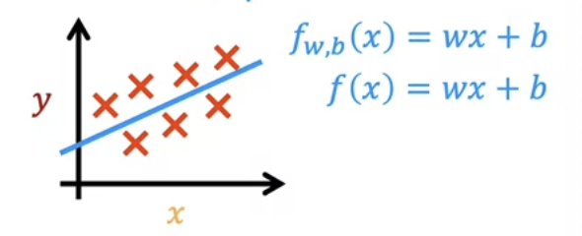

Linear regression with one variable (single feature x) – **univariate linear regression**

### Cost Function Formula

* + Going back to the linear regression function model (*fw,b(x) = wx+b)*
    - *w,b* are parameters/coefficients/weights
      * More specifically *w* is known as the **slope** and the *b* value is the **y-intercept**
      * Variables you can adjust during training to improve the model
      * Examples: 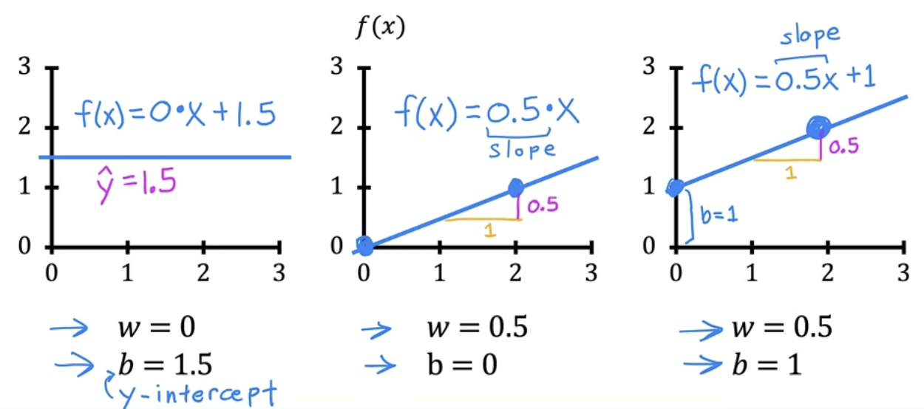
    - Example with training set: 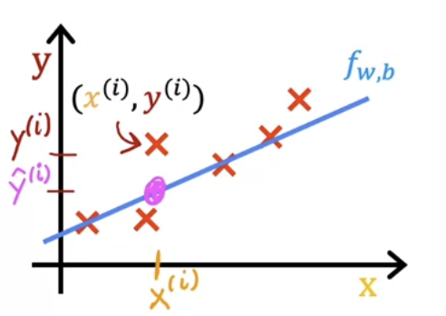
      * The line passing through the points in the data set is roughly passing through the training examples
      * To predict a ŷ value: ŷ(i) = *fw,b(x(i))* or *fw,b(x(i)) = wx(i)* *+ b*
      * To find the best fit line ŷ should be close to *y(i)* for all *(x(i)*, *y(i))*
  + Cost function
    - $ŷ - y= error$ error → how far off from the target the predicted value is
 $J(w,b)=\frac{1}{2m}\sum_{i=1}^{m}{}{{(ŷ}^{(i)}- y^{(i)})}^{2} or J(w,b)=\frac{1}{2m}\sum_{i=1}^{m}{}{{(f_{w,b}(x}^{(i)})- y^{(i)})}^{2}$     * m = number of training examples
      * To prevent the summation function from getting bigger we divide it by the number of training examples (m)
        + In the function above you can see the summation is divided by 2m → this is because to make machine learning a little easier

### Cost function intuition

* + The goal of is to minimize *J(w,b)* by adjusting the values of *w* and *b*
  + Example: $f_{w}(x) = wx$ (in this case *b = 0*)
    - → $Cost Function: J(w) = \frac{1}{2m}\sum_{i =1}^{m}{}{(f_{w}(x^{(i)}) - y^{(i)})}^{2}$

 $f_{w}(x^{(i)}) = wx^{(i)}$     * Goal: Find value of *w* that minimizes *J(w)*
    - Example: For w = 1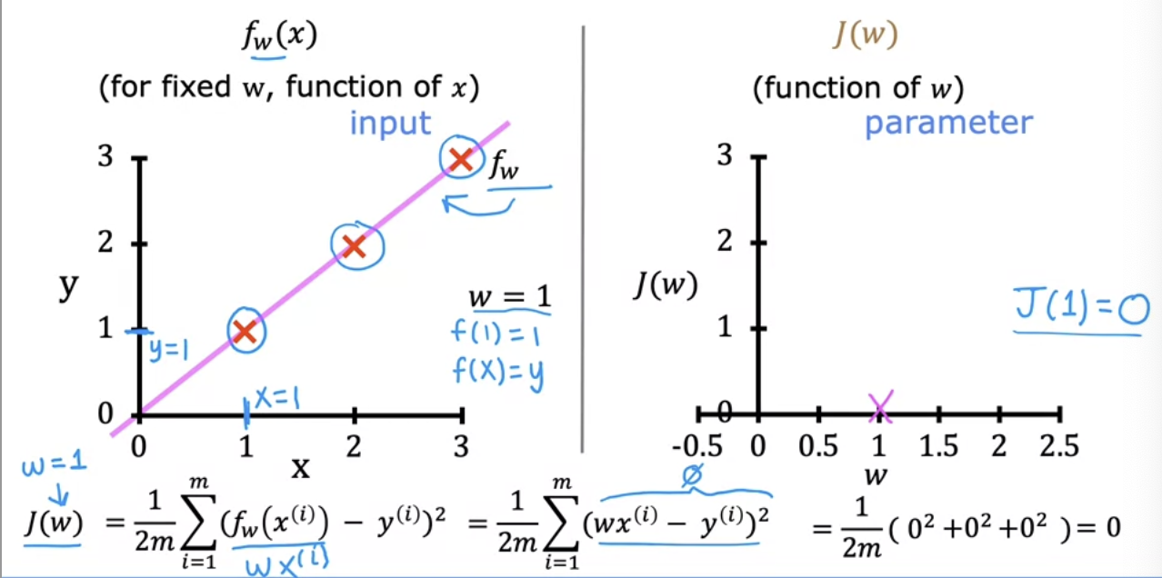
    - Example: For w = 0.5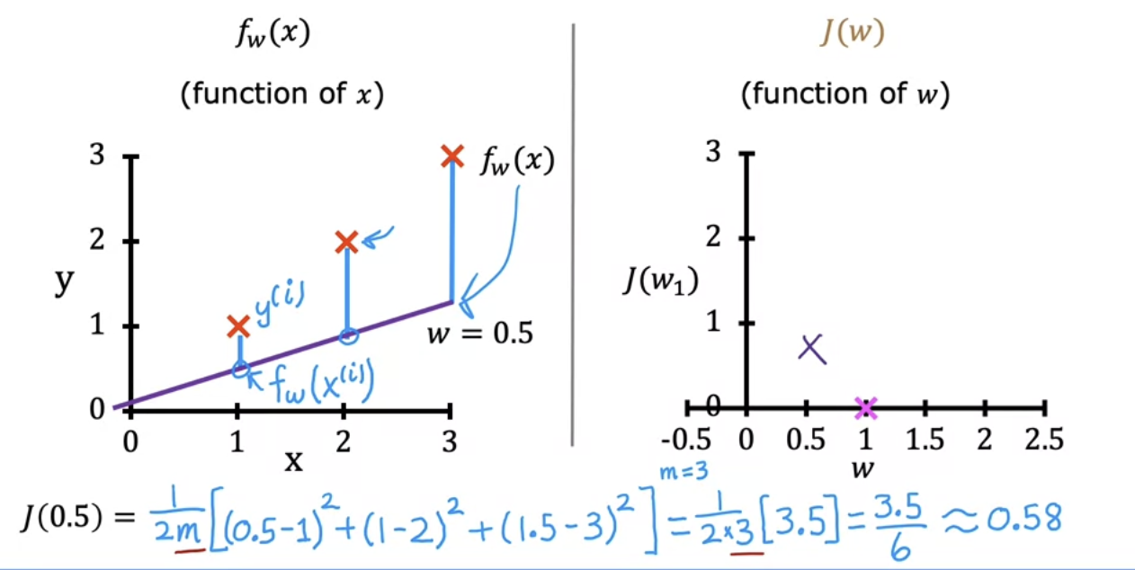
    - Example: w = 0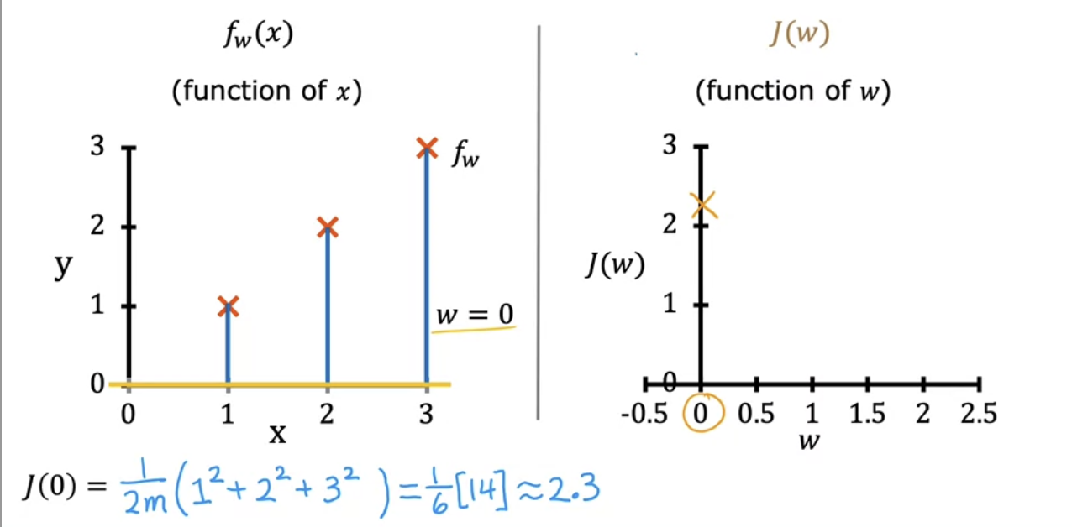
    - Example: Other w values 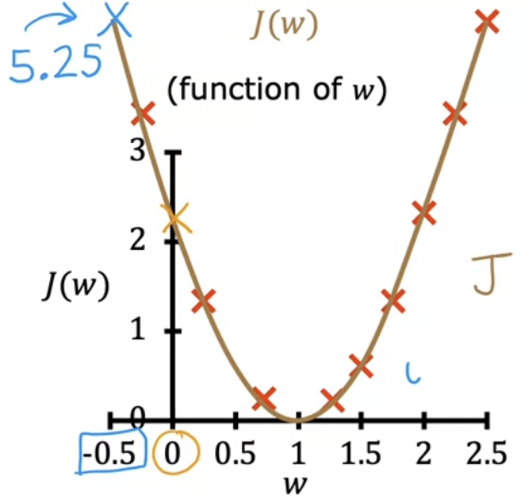
  + How to choose w?
    - Choose *w* to minimize *J(w)* to minimze the square errors
      * For this example you would choose w = 1

### Visualizing the Cost Function

* + We are going to now module *w* and *b*
  + Example: Using this data set and setting w = 0.06 and b = 50 we get the following line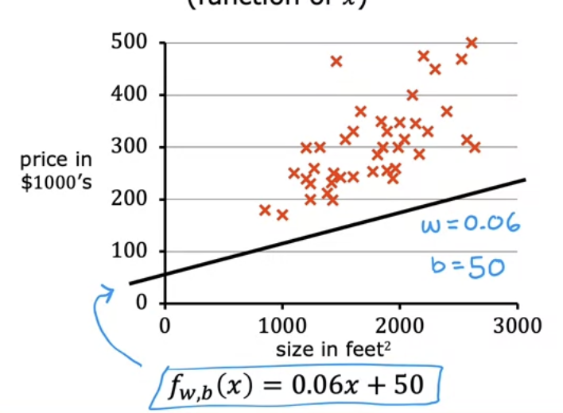
    - → We get this 3-dimensional graph (since we have to now plot w and b) for *J(w, b)*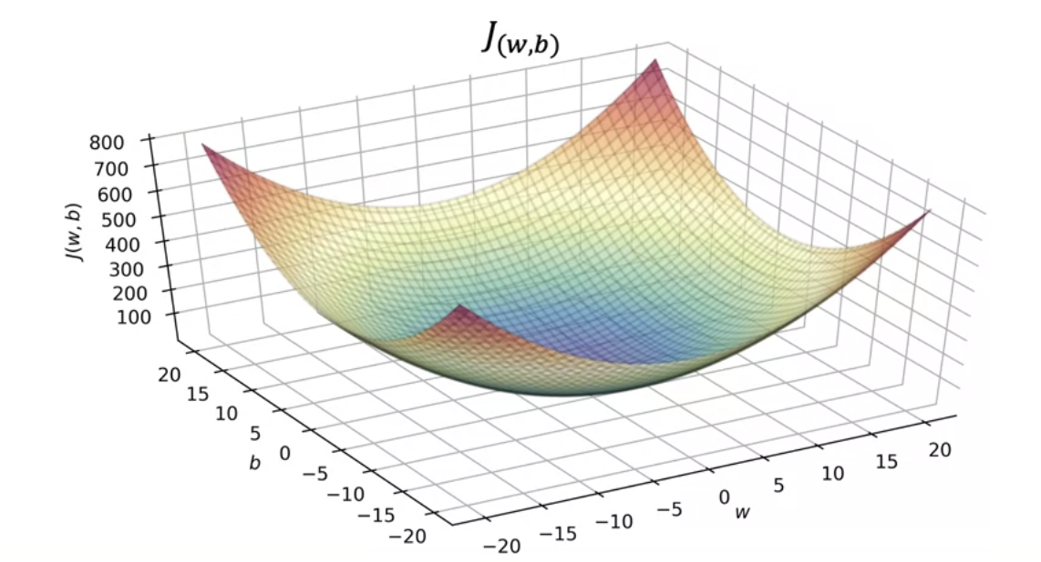
    - While 3-D plots are nice, we can also use a contour plot to visualize 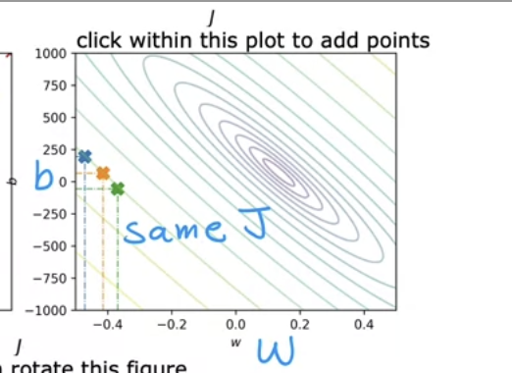
      * Y axis is b and X axis is w
      * Ovals show center points on 3D surface which are the same height or the same cost function (*J*)
      * To get contour plot you have a 3-D plot and slice contours horizontally
        + This way you get all values with the same height
      * Bottom of the bowl where *J* is at a minimum, indicated ideal *w* and *b* values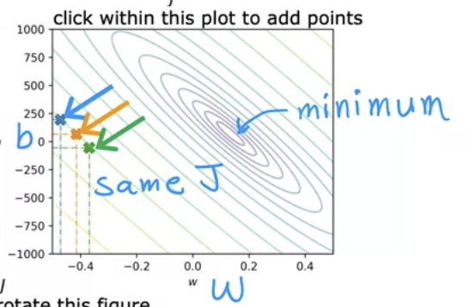

### Visualization Examples

* + Using the function, f(x) = -0.15x + 800, we can see there is a high error margin since the data points are far from the function we chose
    - w = -0.15
    - b = 800
    - → Get this contour plot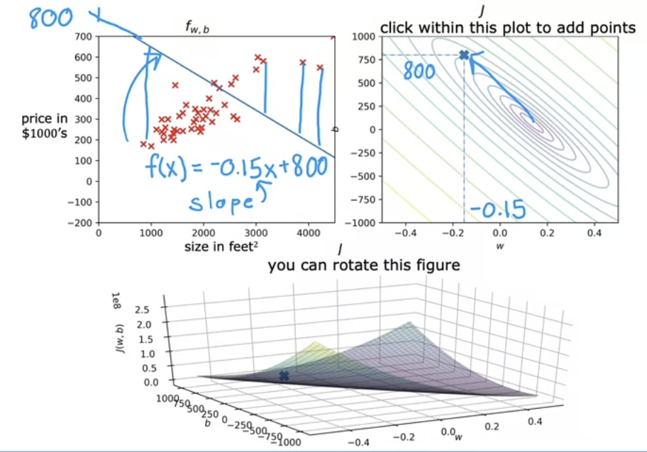
    - Poor since the value is far away from the minimum value
  + Another function, f(x) = 0x + 360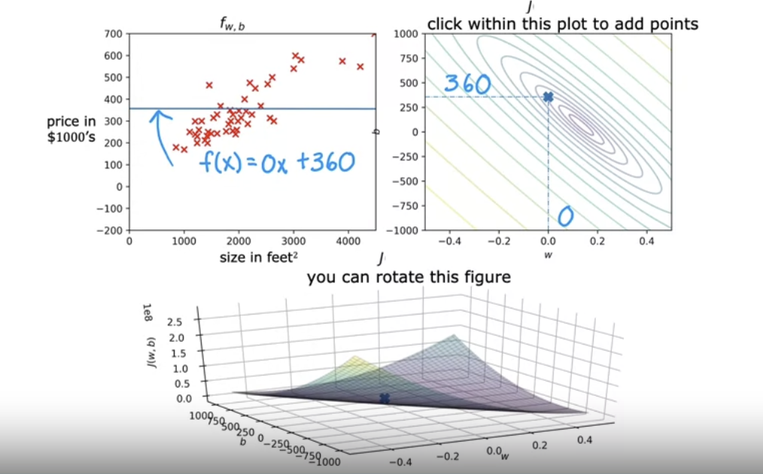
  + And another function where f(x) = -0.15x + 500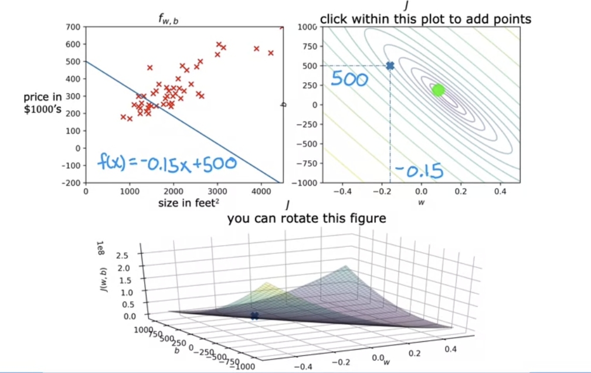
  + And another where f(x) = 0.13x + 71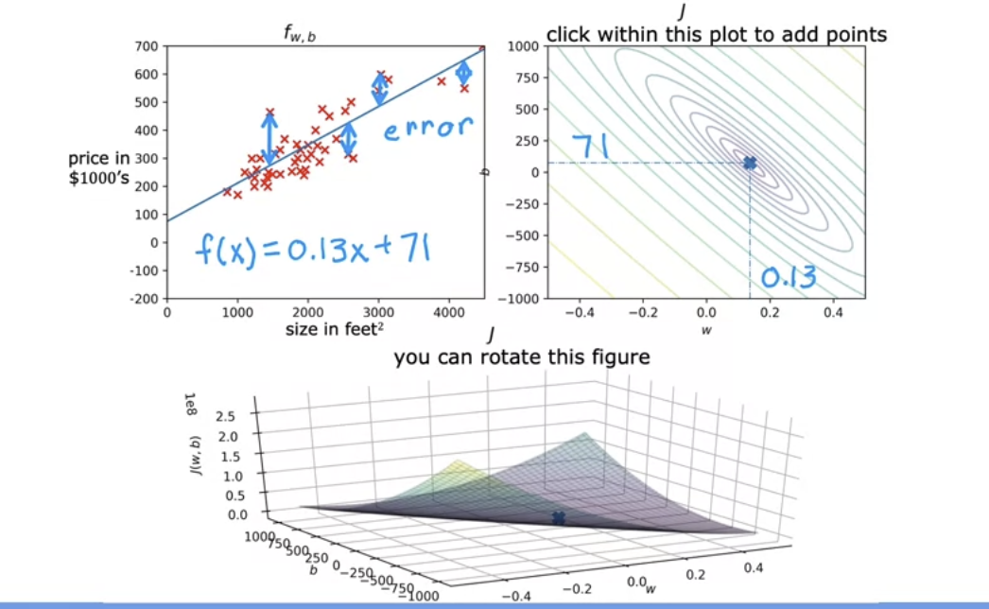
    - Pretty good fit on contour graph with low error rate in regression plot

## Practice Quiz: Regression Model

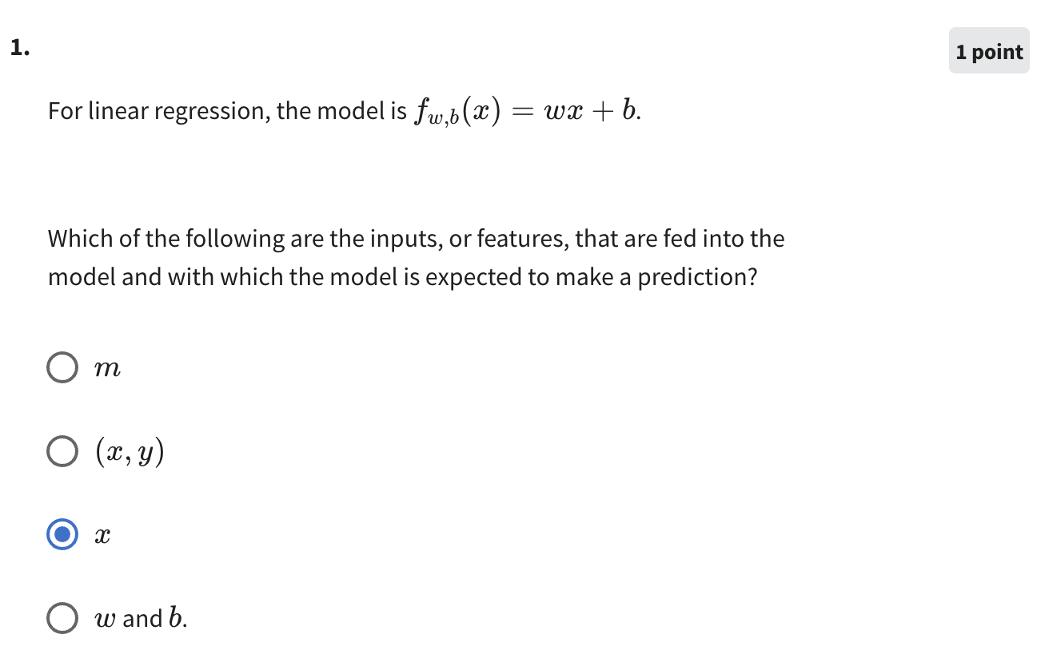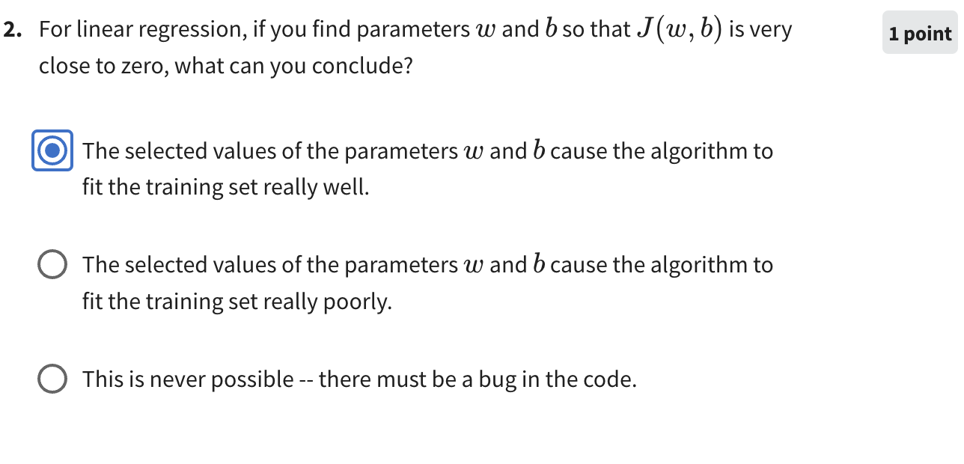

## Train the Model with Gradient Descent

### Gradient Descent

* + You have a cost function *J(w, b)* (which could be used to describe any function and not just linear regression), and the goal is to find the $min J(w, b)$
    - Could also be used for more parameters (*J(w1,, w2, …, wn, b))*
  + Outline:
    - Start with some value for *w* and *b*
      * → Keep changing *w, b* to reduce *J(w, b)* until we style at or near a minimum value
        + Please note for non-parabolic cost function graphs, there can be more than one minimum value
  + Example: 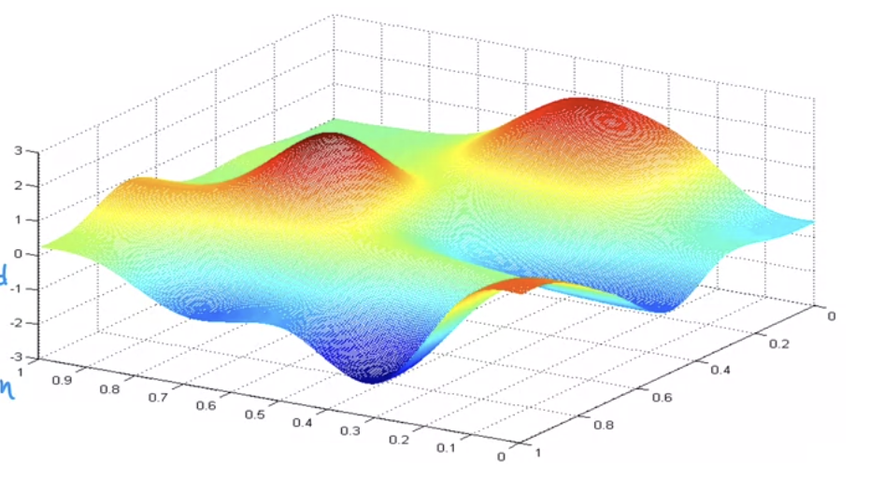
    - Not a squared error cost function and not a linear regression (in linear regression you always end up with a bowl shape)
      * Analogy: 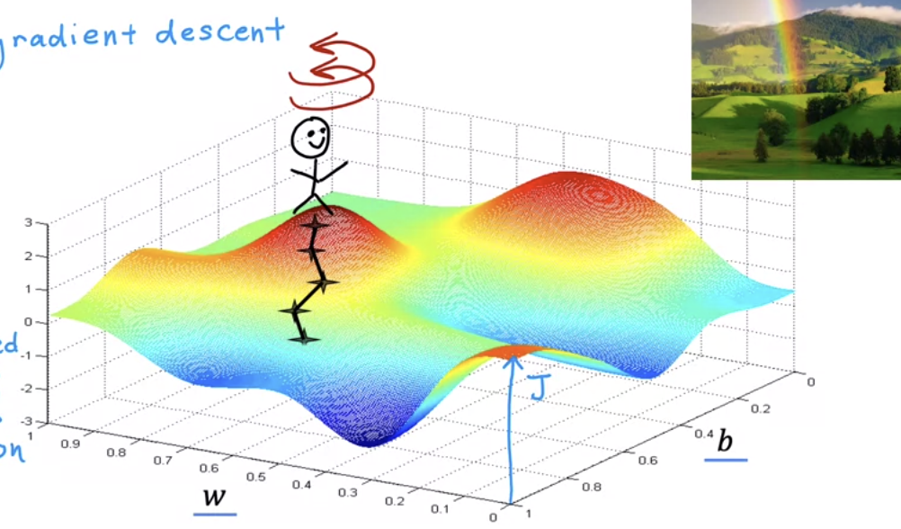
        + Standing on top of a hill and your goal is to get down the hill to the minimum point as fast as possible → you make a 360° turn and evaluate which is the best way and you walk down a little bit → reevaluate your path again → walk down a little bit, etc.

This is the same thing the gradient descent algorithm is doing until you reach a local minimum

Another path can lead to another local minimum if the starting position is changed 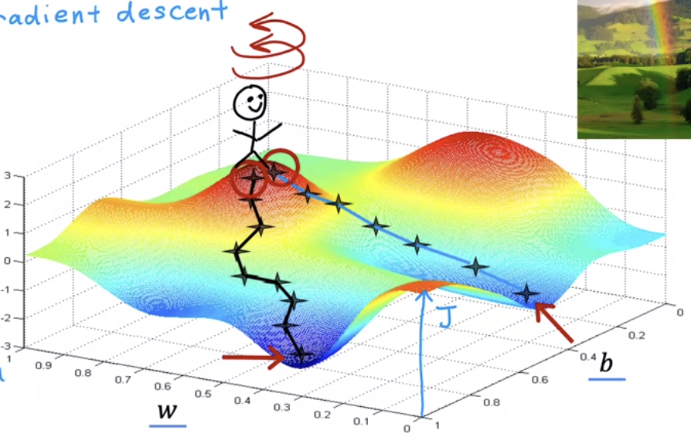

### Implementing Gradient Descent

* + In gradient descent, the value of *w* is updated at every step
    - Formula: $w= w (old value) - α × \frac{d}{dw}J(w, b)$
      * = sign in the equation above is the **assignment operator**
        + This is used in code
        + Conversely in truth assertion for math you can say a = c to mean a and c are of equal values, but you cannot say things like a = a + 1 since that does not make sense in mathematical terms

Written as “==” in code commonly

* + - * is known as the learning rate
        + Usually between 0 to 1
        + Denotes how big of a step you take downhill to try and get to the minimum

The bigger the alpha value the bigger the steps you are going to be taking

* + - * in simple terms is what direction you want to take your step
        + In combination with $α$ it tells us how big and the direction of the step that we want to take downhill
  + The b value is also updated at every step
    - Formula $b = b (old value) - α × \frac{d}{db}J(w, b)$
  + → **The goal is to repeat the steps for the new *b* value and new *w* value till convergence is reached**
    - Reach the point at a local point where *w* and *b* don’t change much
    - Both *w* and *b* are updated **simultaneously**
      * Formulas
 $tmp w = w -α\frac{∂}{∂w}J(w, b)$

 $tmp b = b -α\frac{∂}{∂w}J(w, b)$

      + Note the pre-derivative *w* goes into the function formula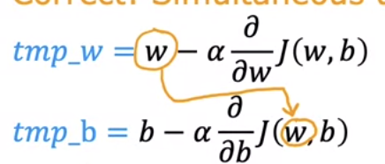
      * → Calculate both the *tmp w* and *tmp b* simultaneously and store the values → copy the value of *tmp w* into w (w = *tmp w*) and the value of *tmp b* into b (b = *tmp b*)

### Gradient Descent Intuition

* + Goal: repeat until convergence {

* + - * What is the derivative?
        + You can draw a tangent line at a point on a line and touches the curve
    - Example: *J(w)* cost function
      * Gradient descent formula then would be $w = w-a$ $\frac{∂}{∂w}J(w)$
        + Goal is to adjust w to get $min J(w)$

Could look at two-dimensional graphs since b can be set to 0

* + - * + →Pick an initial point 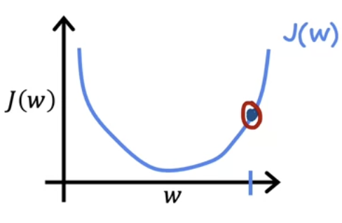
        + → update using $w = w-a$ $\frac{∂}{∂w}J(w)$

Derivative meaning ($\frac{∂}{∂w}J(w)$)

The slope of the line at a specific point in the derivative of the line 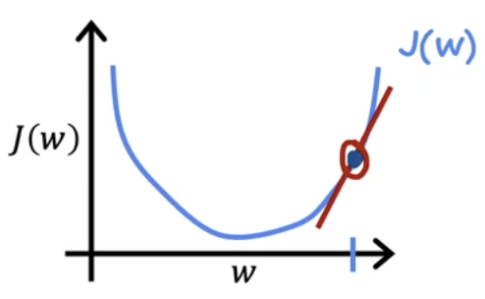

To compute the slope, we can use a triangle and divide the height by the width (2/1)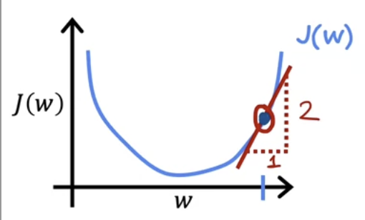

In this case the slope is also positive due to its direction, so the derivative is a positive number → $w = w -α ∙ (positive number)$

Learning rate is always positive → $w = w - (+) (+) = w- (+)$ → new w value will always be smaller (moving to the left in the case of our example). This makes sense because moving left moves us closer to a minimum *J(w)* value

* + - Another example with the same function (*J(w)* cost function)
      * → Starting with a different initial value for *w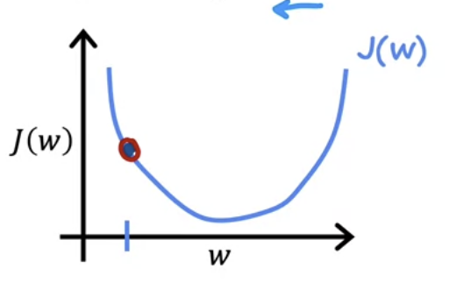*
        + Tangent line is negative in this case because it's sloping down and to the right → derivative function is negative

$w = w -α ∙ (negative number)$

Learning rate is always positive → $w = w - (+) (-) = w- (-) = w + (+)$

New *w* value in this case will be bigger (moving to the right on the graph). This makes sense because moving right moves us closer to a minimum *J(w)* value

* + Learning Rate
    - Going back to the formula: $w = w-a$ $\frac{∂}{∂w}J(w)$
      * $α$ is the learning rate
        + If $α$ is too small, you multiply the derivative term by a small number → take a really small step toward the minima 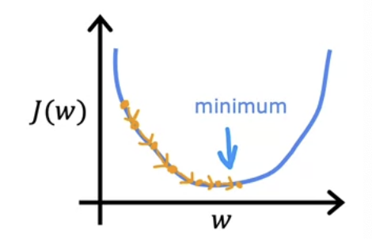

You eventually get to the minimum but in a lot of steps and really slowly

* + - * + If $α$ is too big, you multiply the derivative term by a big number → could potentially overshoot the new *w* value corresponding to the minima that you get 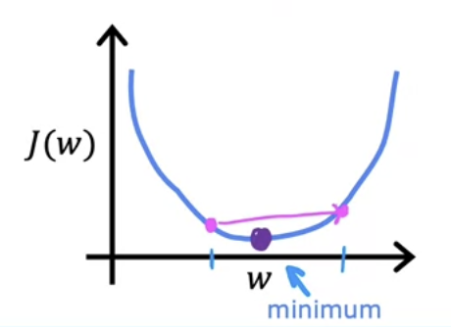

Cost has actually increased in this example which is not what you want → could never reach the minimum and fail to converge or even diverge

* + - Another example: *w* is already at a local minimum 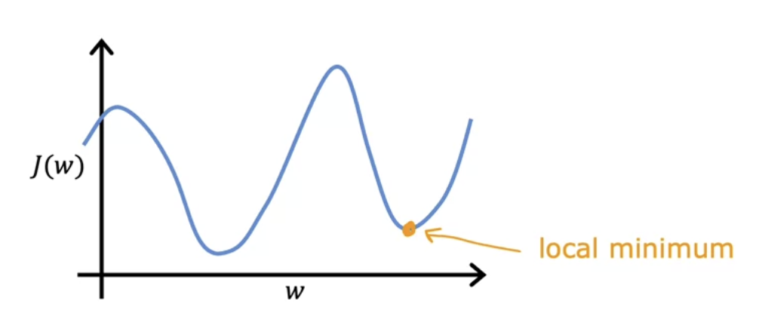
      * Not a square error cost function with two local minima
      * If you draw a tangent line to the local minima, the slope will equal 0 and the derivative function in $w = w-a$ $\frac{∂}{∂w}J(w)$ will also equal 0 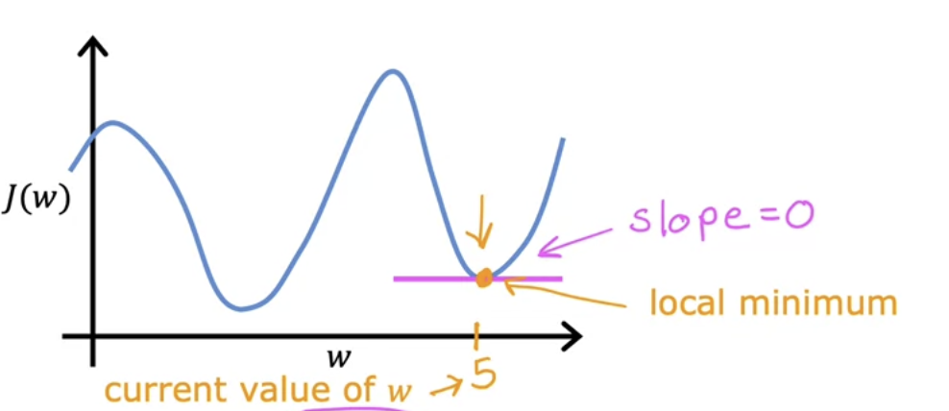
        + → $w = w-a⋅0→ w=w$

If you are at local minima, gradient descent will leave *w* unchanged

* + - * **If you reach a local minimum, gradient descent will not work** 
        + Gradient descent can reach a local minimum with a fixed learning rate

Example: $w = w-a$ $\frac{∂}{∂w}J(w)$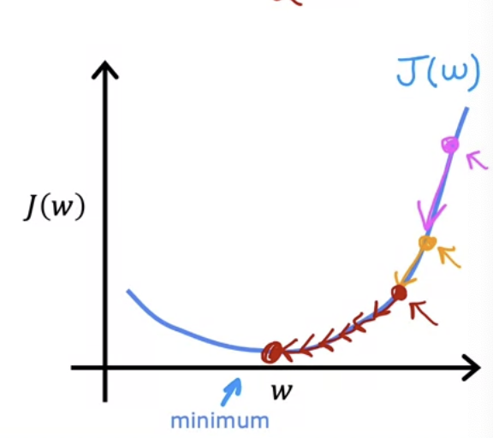

If you start with the first value, there is bigger slope tangent to the point, derivative function will be large

→ Going to the next value for *w*, the derivative will be smaller, and then smaller as we approach the minimum value, etc.

### Gradient Descent for Linear Regression

* + Linear Regression Model
    - Function: $f_{w,b}(x) = wx +b$
    - Cost Function: $J(w,b)=\frac{1}{2m}\sum_{i=1}^{m}{}{{(f_{w,b}(x}^{(i)})- y^{(i)})}^{2}$
  + Gradient Descent Algorithm
    - repeat until convergence {

$w = w -α\frac{∂}{∂w}J(w, b)$ → $\frac{1}{m}\sum_{i=1}^{m}{}{{(f_{w,b}(x}^{(i)})- y^{(i)})x^{(i)}}^{}$ (derivative of cost function with respect to w)

$b = b -α\frac{∂}{∂w}J(w, b)$ → $\frac{1}{m}\sum_{i=1}^{m}{}{{(f_{w,b}(x}^{(i)})- y^{(i)})}^{}$ (derivative of cost function with respect to b)

}

* + - Could implement gradient descent with the summation formulas
  + Gradient Descent Alogirithm for Linear Regression
    - repeat until convergence {

}

* + - * Want to update *w* and *b* simultaneously on each step
  + Gradient Descent Problems
    - Could lead to local minimum rather than global minimum
      * Where you initialize the parameters *w* and *b* could lead to different local minima 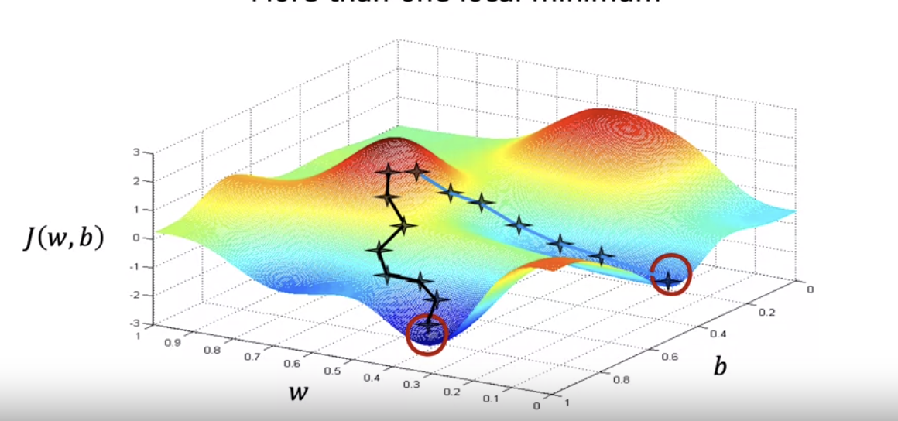
      * When using a squared error cost function with linear regression this is not a problem as there is only one global minima due to it being a convex function 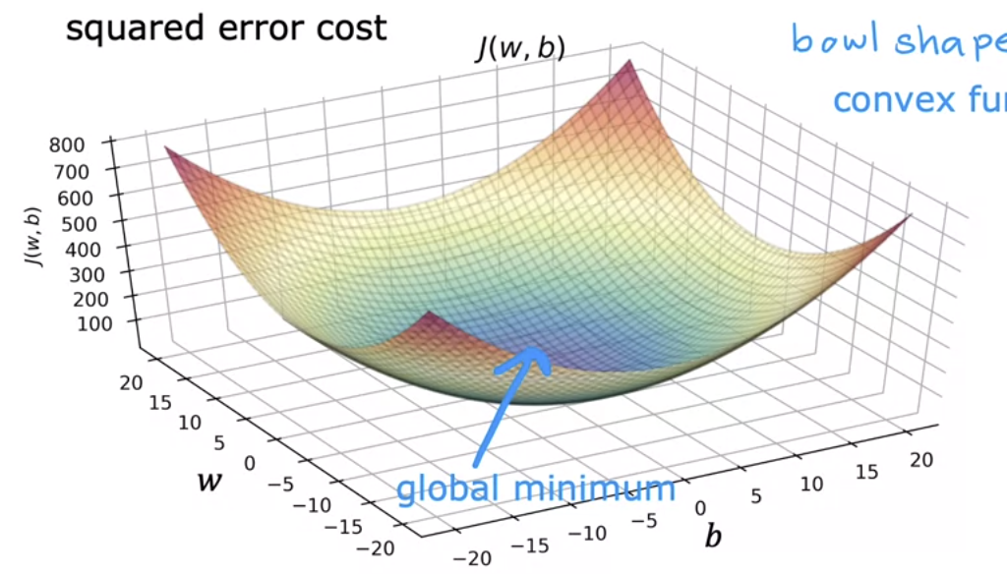

### Running Gradient Descent

* + Example: f(x) = -0.1x + 900 for initial starting for a data set
    - Cost function slowly moves to decrease the cost as gradient descent continues 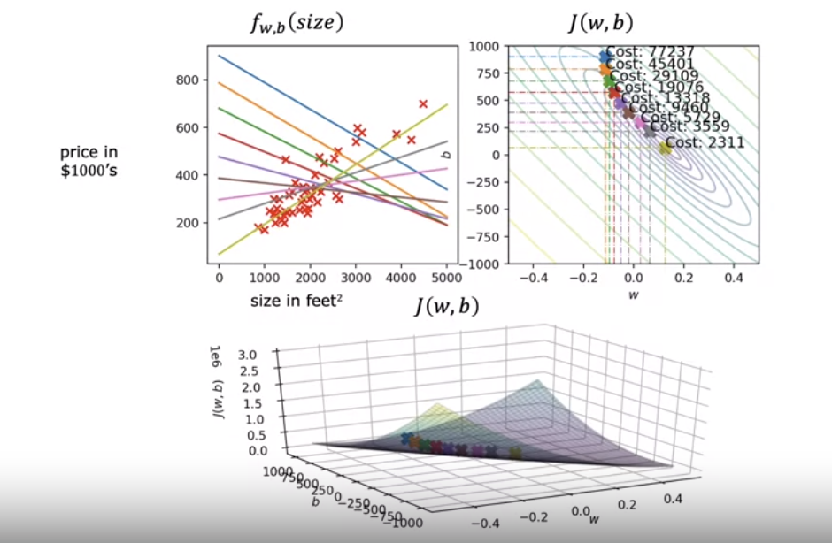
      * This gradient descent process is called **batch gradient descent**
        + This means that on every step of gradient descent we are using all the training examples rather than a subset of the training data
* Practice Quiz: Train the Model with Gradient Descent

